Oil Tank Swap from AFYMAT to OMFB

What you need

2” X 1 1/2 “M X M ADAPTER FOR THE BACK OF THE TANK

2” Ball tap for the on/off lever

2” M X M adapter to go onto the Ball Tap

2” compact 90 to go onto the M X M

Female 2” Hose Tail

Filter for top of tank make sure to put 1” pipe cut at 400mm onto bottom of filter and use 30-40mm jubilee clip to attach to pipe and tighten accordingly

Rubber Seal for Filter

1/4 M X M adaptor for Leak off at top of Tank Has to get welded into tank

1” M X M adaptor for Filter

1” Tee Piece For filter connect Pipes to Tee piece

Filler Cap for Oil Tank to be bolted to holes that are already there

Step by Step

1. Get OMFB Tank box and all fittings out

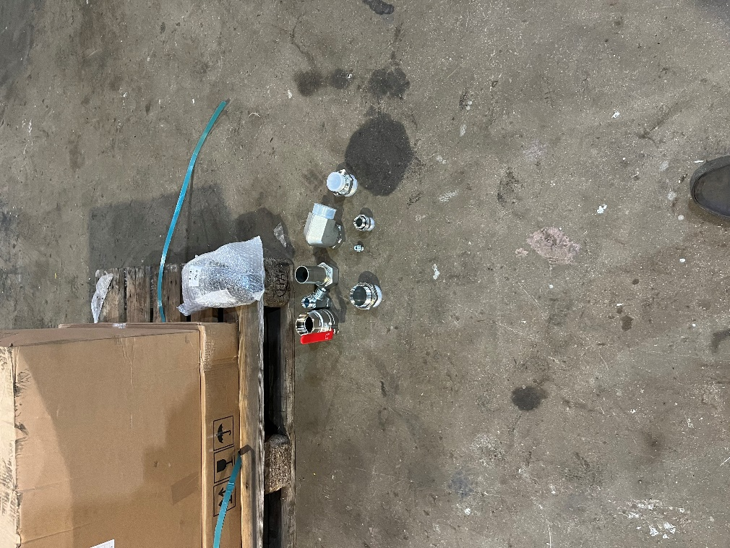

1. 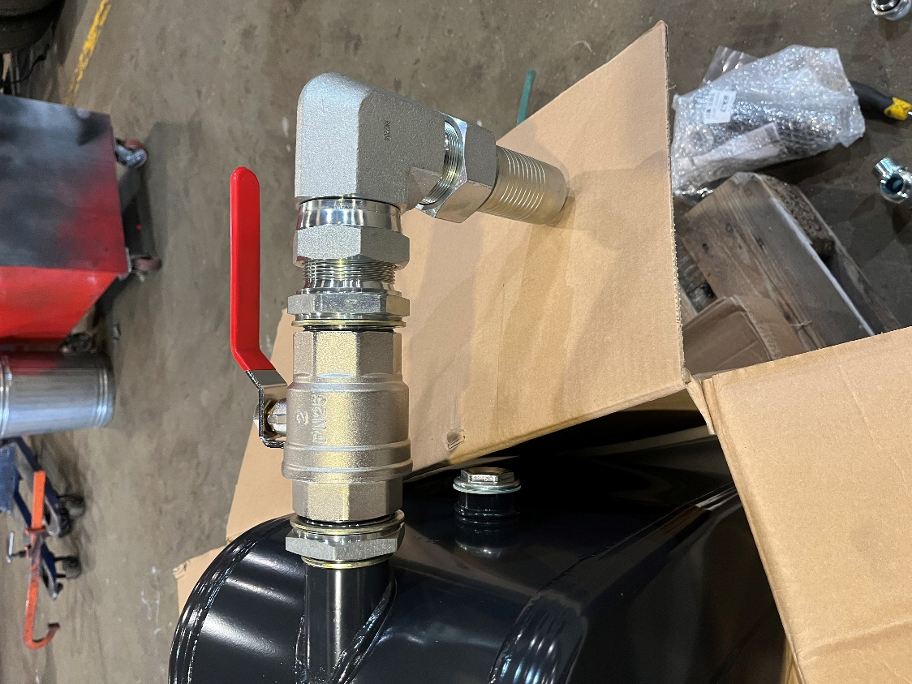Set up behind the tank all the fittings needed so make sure to put 1 ½ male to 2” in first with 2” dowty and screw into tank, once tightened up with socket or spanner, put dowty onto 2” side and use PTFE and oil seal around the fitting make sure use enough to seal the ball tap on, Once that ball tap has been tightened up put a 2” M x M into ball tap with Dowty, PTFE and oil seal, Now leave that because the compact 90 in the photo can be put on once the tank is secured with brackets.
2. 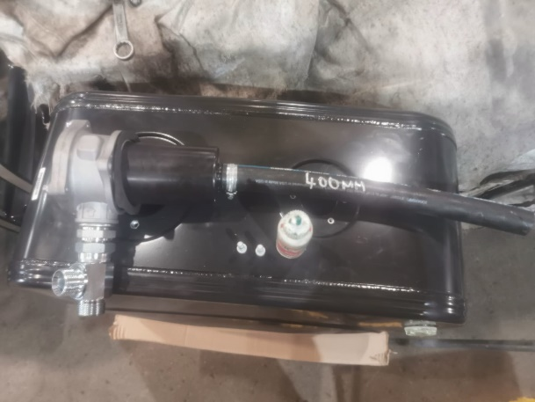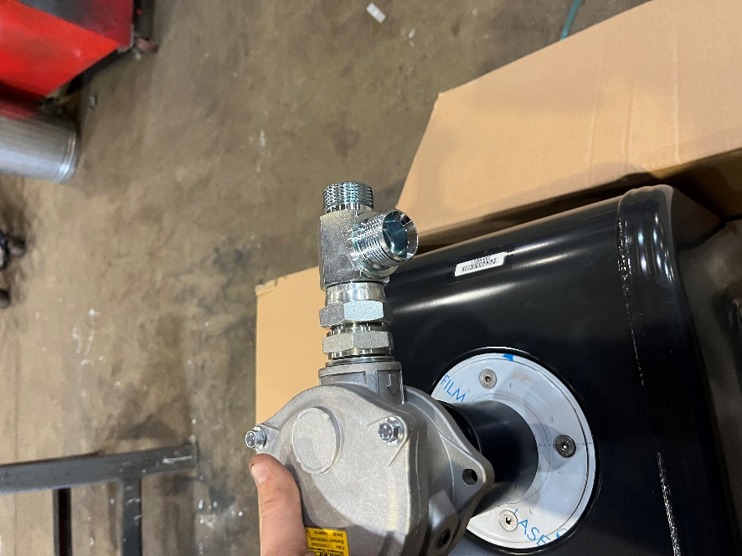Now we have to put the filter on that comes in the Kit this should come with O-ring and seal with the bolts to hold down, We need to use the 400mm 1” hose and 30-40mm jubilee clip and put onto the bottom of the filter and tighten up the jubilee clip, Once that has been put on then we need our 1” M X M fitting and screw onto the filter as shown on the photo and also screw on the T Piece to the fitting.
3. 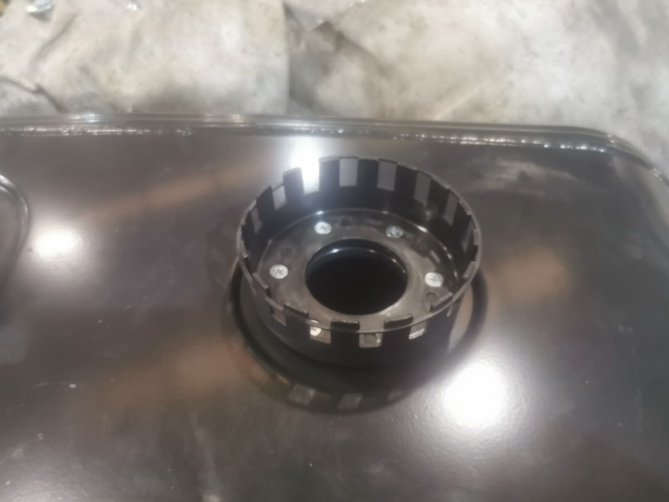Now we need the screw the filler cap into the Tank and this is done by using the screws that are in the kit and tightening them to the filler cap as shown below, the photo below is the finished product.

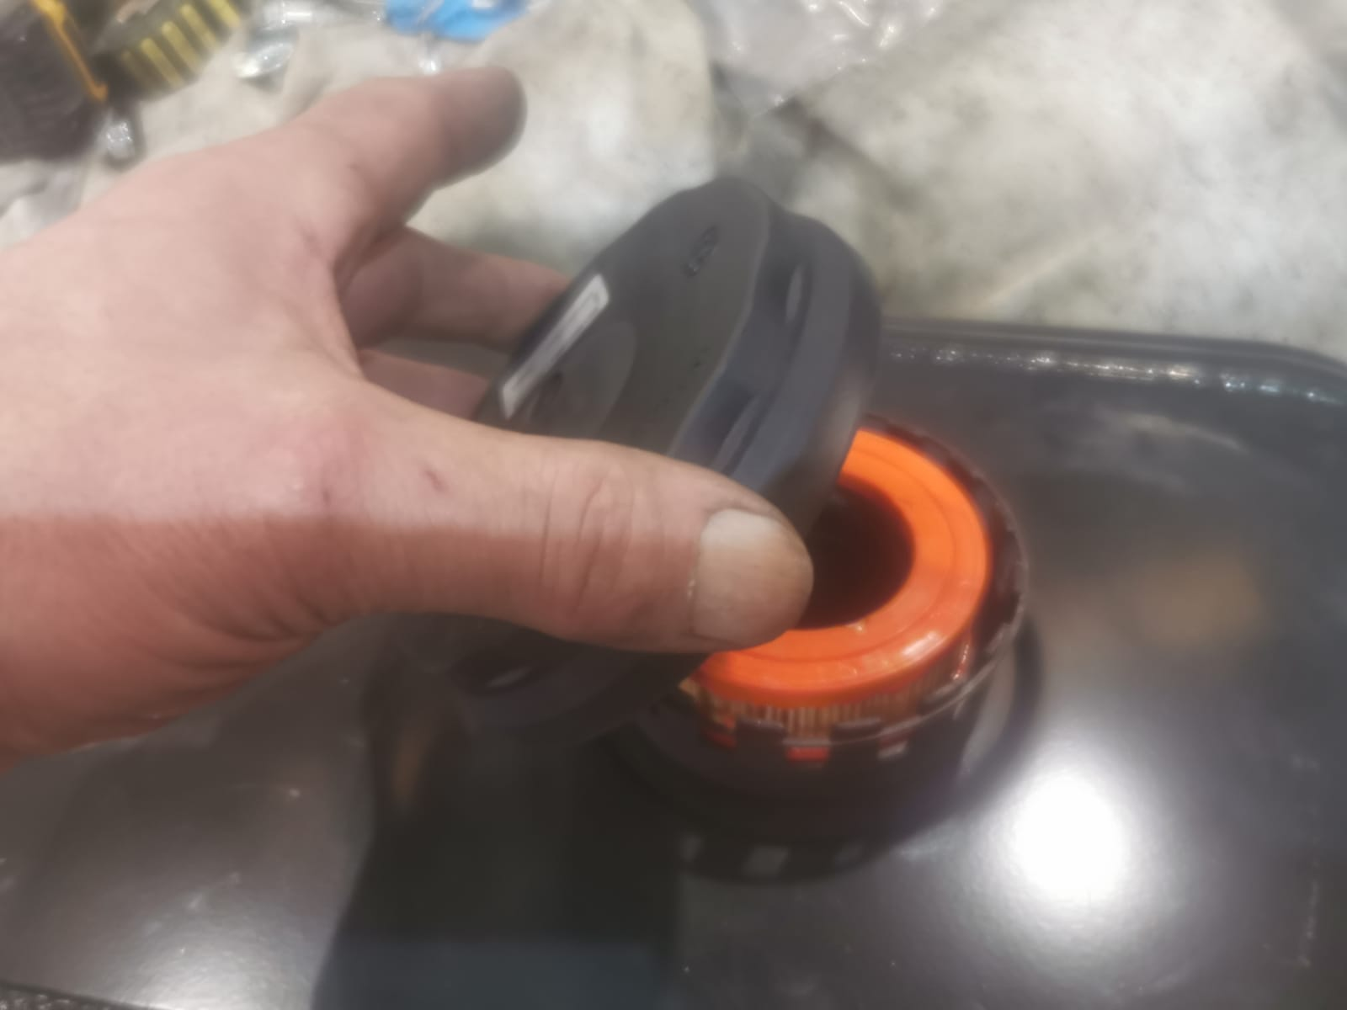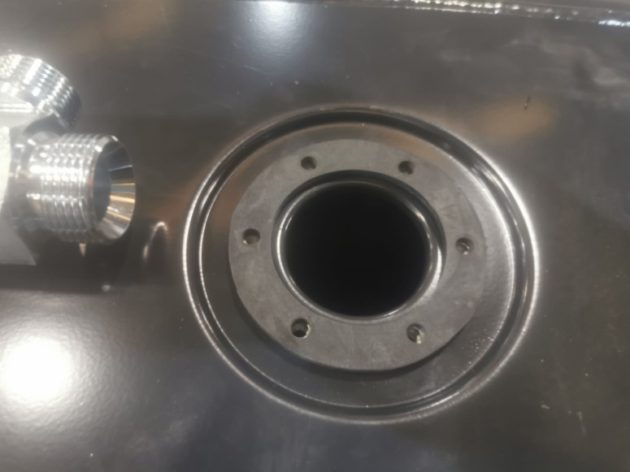

1. 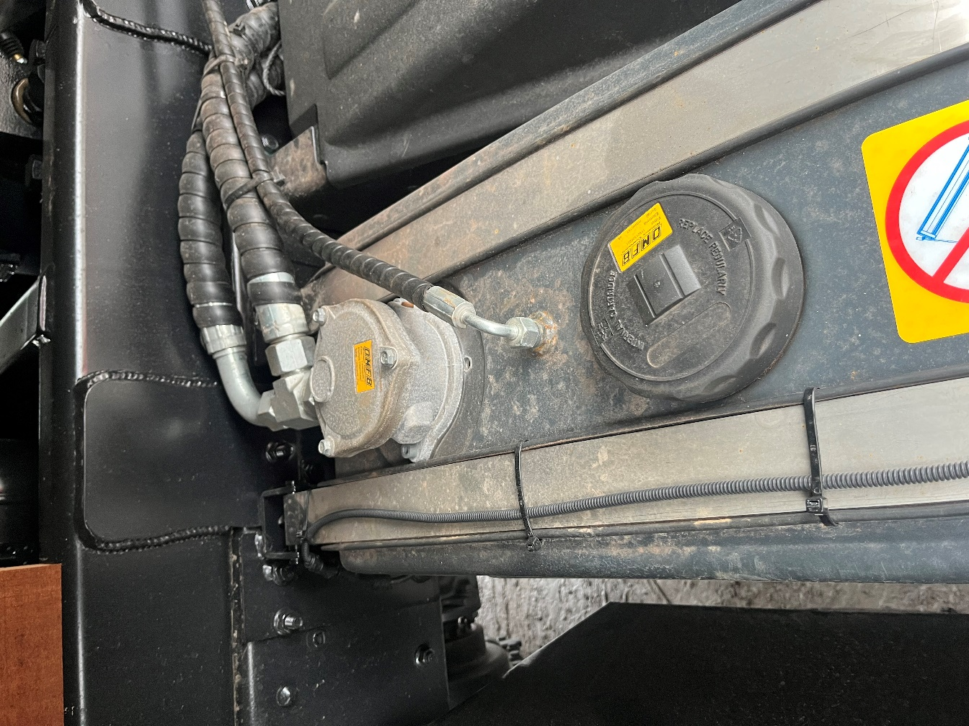Now we need to drill our hole for the leak off fitting which is ¼ M X M so using a Vernier or tape measure you need to measure the size of the fitting and drill the hole in between the filler cap and the filter and once drilled then we will need to weld the fitting to the tank as shown below
2. 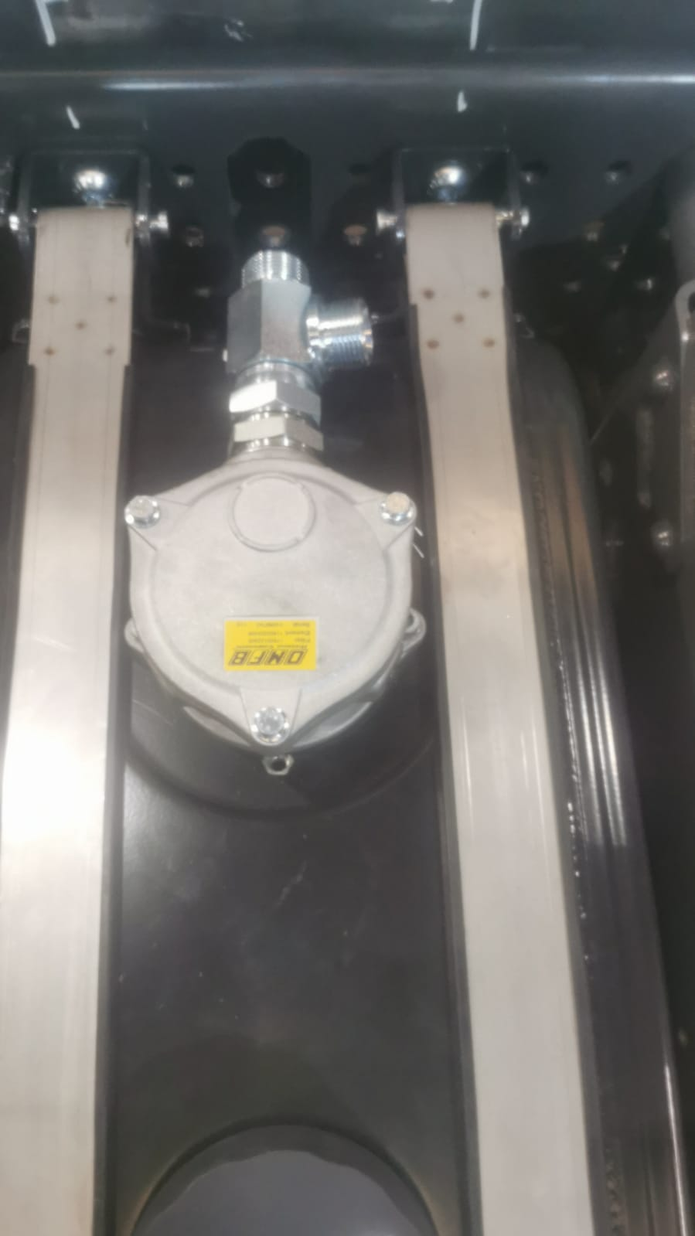Now the tank is all set we now need to set the brackets onto the chassis and this is done by measuring the tank and finding the width and how far apart the brackets need to be. The picture below is a photo of how it needs to be bolted so dome head at the top M16x50 with flange on the other side and M16x50 for the bottom ones. The other photo is the position the straps need to be in to fit as if they are too wide the strap won’t be doing anything as it will not be on the tank and it will be too close to the welds

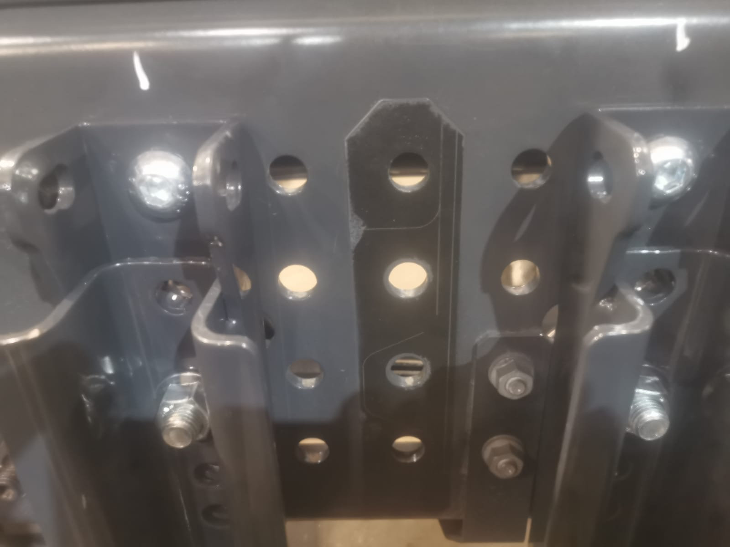

1. 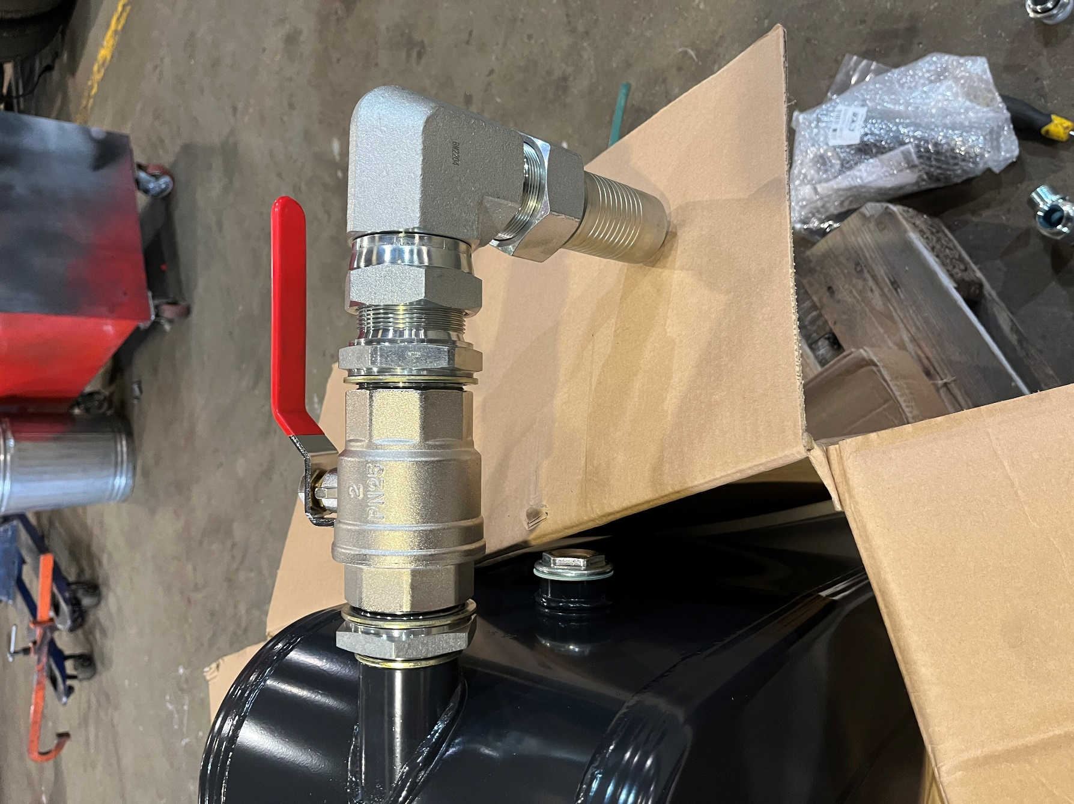Once you have got the measurements of width and the bracket is bolted on then you will need to put the tank on and put the straps on with rubbers and tighten up to the bracket, once bolted on then you will need to put the compact 90 2” at the back of the tank and put the 2” hose tail Female onto the compact 90 as shown below, this does not need any dowty or PTFE
2. Now all that is put together it is time to pipe up which is straight forward

leak off ¼ pipe into the small fitting that you welded to the tank

and the two other pipes are put onto the T piece behind the filter

Connect the 2” hose with clamp that is in the kit supplied with us

The below is the picture of finished product

